New and improved for Vault 2013, Project Thunderdome is here. Based on user feedback I re-designed the entire app. Things should be much more intuitive and easy to use this time around. The features are basically the same, but different in every possible way.
If you have no idea what Project Thunderdome is, sit back and strap yourself in. You are about to get Thunderdomed....

There, you just got Thunderdomed. If you feel exactly the same as before, that means it’s working!

Requirements:
Vault Workgroup/Collaboration/Professional 2013
Click here to download application
Click here to download source

Features:
- Backup user settings - A quick way to zip up all your Vault user-settings.
- Create admin deployments - Select the components you want to deploy and they will be pushed to all other users with Thunderdome.
Components include: User settings, saved searches, plug-in, DECO files, and vLogic scripts.
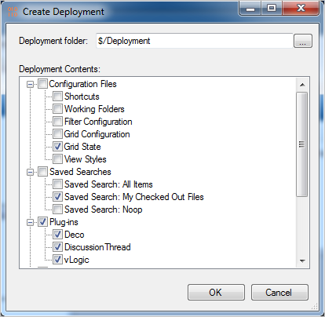
When an update is ready, user’s see something like this when they log into Vault Explorer.
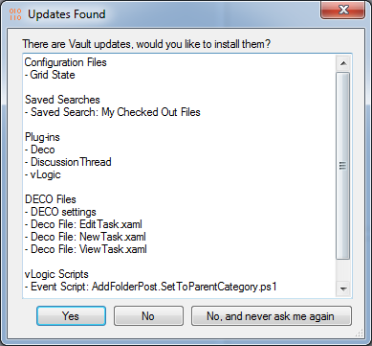

As with all the samples on this site, the legal disclaimer applies.

